FLUENT VALIDATION
THIS VALIDATION IS USE FOR COMPLEX VALIDATION
- Install latest package FluentValidation.AspNetCore in Application Module
- In Application Module, create Restaurants/Validators/CreateRestaurantDtoValidator.cs
  - Make it public class
  - Inherit AbstractValidator class
    - Enter the class that we want to validate, in our case is CreateRestaurantDto.cs
  - Create a constructor that is going to define the validation rules with some specific methods
    - Create all the rules for validation here
- Remove the old validation in CreateRestaurantDto.cs
- Edit ServiceCollectionExtention.cs in ApplicationModule
  - Add a new service called AddValidatorsFromAssembly()
  - Add also AddFluentValidationAutoValidation

STEP BY STEP TUTORIAL

- Install latest package FluentValidation.AspNetCore in Application Module
- In Application Module, create Restaurants/Validators/CreateRestaurantDtoValidator.cs
  - Make it public class
  - Inherit AbstractValidator class
    - Enter the class that we want to validate, in our case is CreateRestaurantDto.cs
  - Create a constructor that is going to define the validation rules with some specific methods
    - Create all the rules for validation here
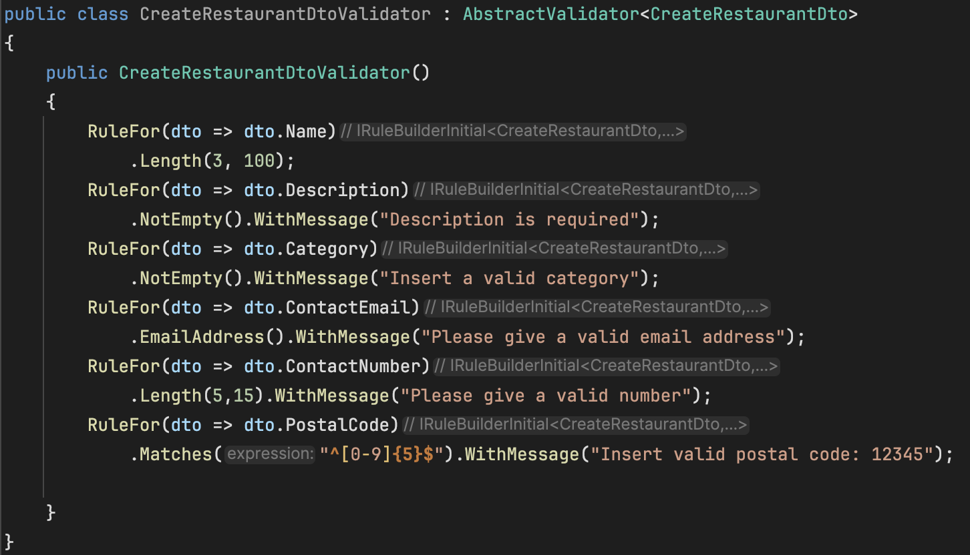
- Remove the old validation in CreateRestaurantDto.cs

- Edit ServiceCollectionExtention.cs in ApplicationModule
  - Add a new service called AddValidatorsFromAssembly()
  - Add also AddFluentValidationAutoValidation
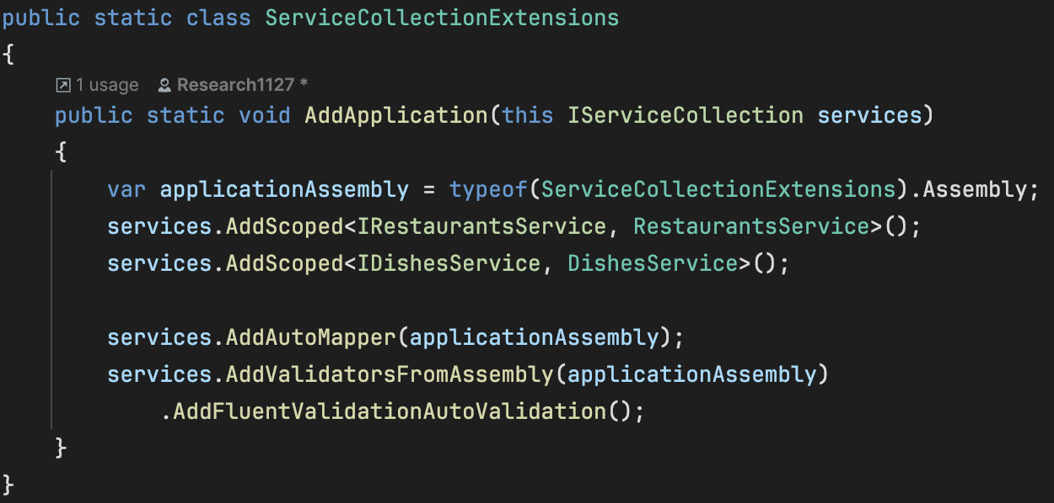

- Run the web app and check using swagger

